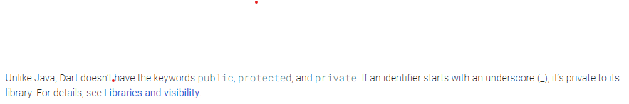

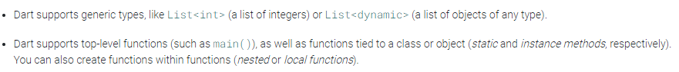

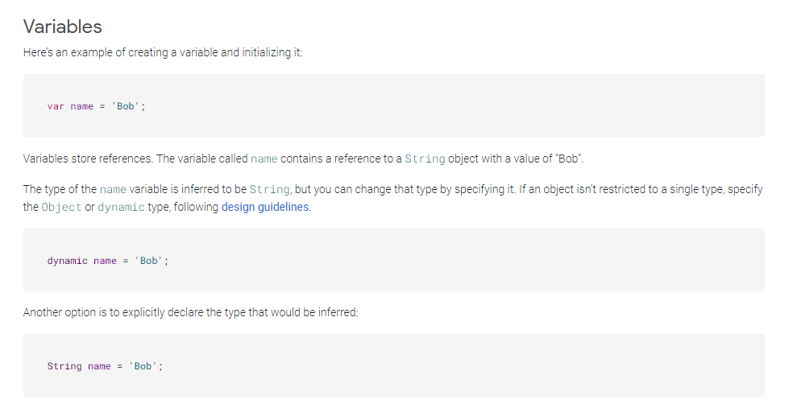

* List/array we delcary with []. Map use {} to declare.
* Final is a runtime constant, const is a compile time constant. That means final values are become constant after program is ran, while const variables are set while compiling the code.